Giulietta Schutte
Statistical Ecology Final

Introduction:
While a newer field of research, conservation behavior has been argued to be an incredibly important component of wildlife conservation efforts, lending itself to issues such as anticipating habitat requirements of species, reserve design, release schemes and census techniques, to name a few (Sutherland). This project focuses on the results of the study Insights into artificial waterhole utilization patterns by elephants and rhinos: Lessons from a South African Nature Reserve, to answer the following three questions: Is there a relationship between duration of visit and number of animals at a species’ preferred watering hole type? Is there a relationship between duration of visit and season at a species’ preferred watering hole type? How do these relationships compare between the three tracked species; the endangered African savanna elephant (Loxodonta africana), the critically endangered black rhino (Diceros bicornis), and the near threatened white rhino (Ceratotherium simum)? The original study, conducted by authors Smith, Brown and Barrett, analyzed waterhole usage patterns of the African savanna elephant, black rhino and white rhino within the context of Olifants West Nature Reserve (OWNR) located within southern Africa. Camera traps monitored four different types of artificial waterholes; earth dams, concrete pans, reservoirs and troughs, 24/7 from January to December of 2013. Population densities were not available to the authors of this study due to high poaching risks. Since population densities are unknown due to security concerns and the spatial layout of waterholes in regards to such densities are unclear, a simple count of individual visits to waterholes per species is not sufficient in itself. Therefore, it is necessary to pair it with recorded duration to track usage per species in the most simplistic form possible. This information should be placed within the contexts of previously established species behavior regarding water and social interactions.

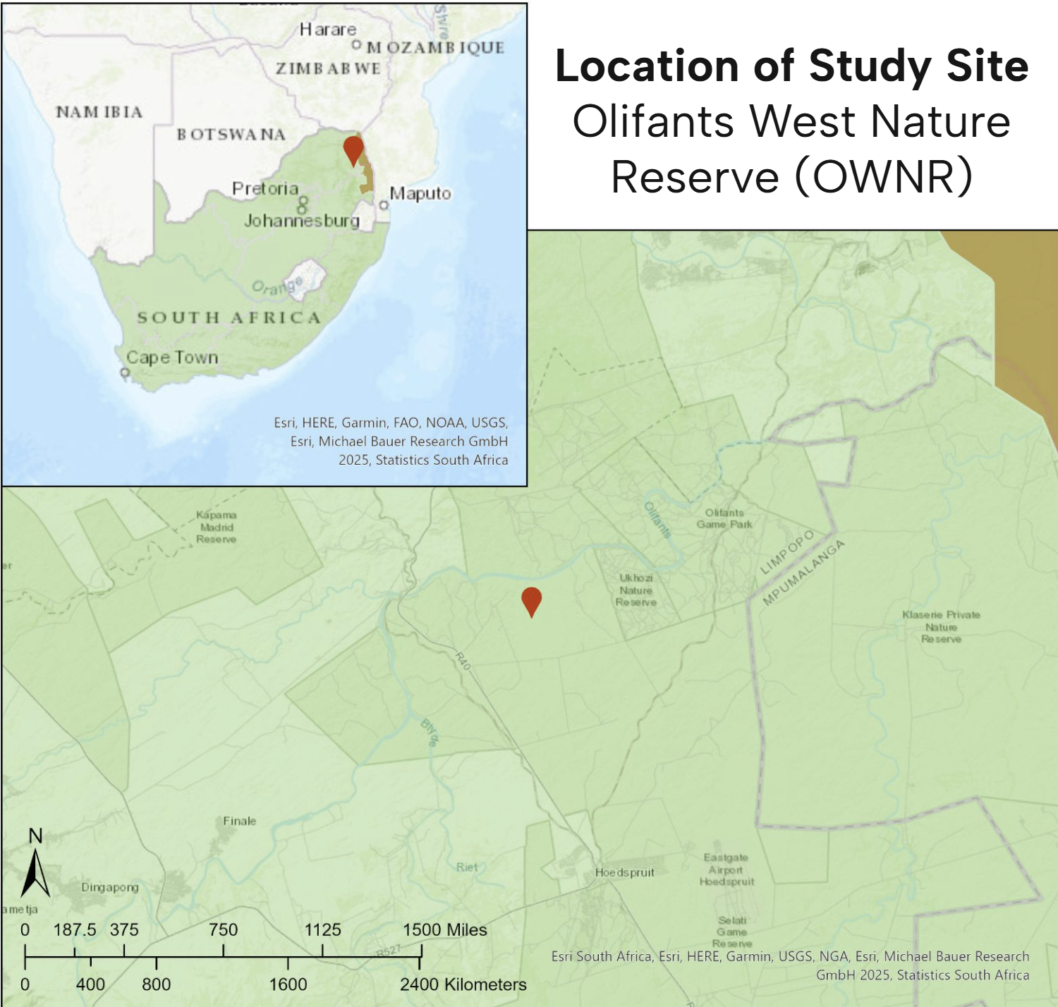
Figure 1: Location of study area with Kruger National Park in gold. (Chenary)(Esri)(Smith)
At the conclusion of this project, it was found that while seasons did not have a statistically significant impact on the length of duration each species spent at their preferred watering hole type, the number of animals did have a statistically significant impact on the duration each species spent at their preferred watering hole type.

Materials and Methods
The original study conducted by Smith, Brown and Barrett, and its data, was collected from PLOS One. The authors of this study used camera traps for the 24/7 monitoring of four different types of artificial watering holes - earth dams, concrete pans, reservoirs, and troughs - for the year 2013. Multiple camera trap brands were used, but all brands were reported to have similar specifications with standardized settings to take photos every 1.2 seconds once movement was detected. All cameras had infrared capabilities to capture data at night. Dates and times were synchronised and field-of-views overlapped to ensure individuals were not double counted or missed. Prior to the start of data collection, camera traps were placed in their positions for two-weeks to both check effectiveness and to desensitize animals to their presence. All waterholes were within the confines of OWNR. The authors of the study collected multiple variables, all of which were relevant to evaluating waterhole usage within the context of each species. These variables included, but are not limited to, potential for intra and inter-species interactions, climate data, season, surrounding woody vegetation, date, ground access, and waterhole characteristics. Additional data that would have been interesting to collect would have been water quality tests, especially those in regards to fecal type and amount as well as interaction type (drinking, wallowing, swimming, etc.).

Smith, Brown and Barrett determined preferences for waterhole types based on species and species social groupings, broken down by season and daily period. The variables waterhole size, ground access, woody species density, and woody species height were limited to the number of watering holes in each watering hole type group (earth dam n=3, concrete pan n=3, reservoir n=3, trough n=2). Therefore, this project focused on the relationship, if any, between the duration in minutes of each visit and the number of animals at the watering hole at the time of the visit as well as the visit’s season. This relationship was studied within the context of each species preferred watering hole type, as determined by the authors of the original study.

The original data set was uploaded into Google Sheets, wherein the date formatting was standardized and the season data was added. Season data was found by comparing the date of the observation to what the original authors considered to be the wet and warm season [1] and the cold and dry season [2]. Afterwards, the updated version of this dataset was uploaded into RStudio (R Core Team) using the readxl package (Wickham), wherein further cleaning was conducted to reclassify variables as needed. The data was then broken down by species and their preferred watering hole type. For example, the preferred watering holes of elephants were reservoirs, therefore the elephant watering hole data only included observations of elephants at reservoirs. Afterwards, GLM gamma models were used to investigate how duration was affected by the number of animals at the watering hole and the season of the visit. To compare models, summaries and their AICs were used. The best models were used to create scatter plots with fitted regression lines and confidence intervals using the ggplot2 package (Wickham) and were statistically analyzed using ANOVA tests.

Results

ANOVA statistical tests
> anova(eleQ1mod2,eleQ1mod3,test="Chisq")
Analysis of Deviance Table

Model 1: DurationMins ~ NoAnimals
Model 2: DurationMins ~ NoAnimals + Season
Resid. Df Resid. Dev Df Deviance Pr(>Chi)
1 87 172.04
2 86 169.77 1 2.2747 0.2755

> anova(blkrhnQ1mod2,blkrhnQ1mod3,test="Chisq")
Analysis of Deviance Table

Model 1: DurationMins ~ NoAnimals
Model 2: DurationMins ~ NoAnimals + Season
Resid. Df Resid. Dev Df Deviance Pr(>Chi)
1 70 189.1
2 69 187.4 1 1.7017 0.2991

ANOVA statistical tests show a comparison between models 2 and 3, to test if adding season as a variable increases model fit. A lower deviance indicates a better fit, however the change in both species is so small that the improvements are not significant, indicated by the p-values of 0.2755 and 0.2991 for elephants and rhinos respectively.

Model Summaries

> summary(eleQ1mod2)

Call:
glm(formula = DurationMins ~ NoAnimals, family = Gamma(link = "log"),
data = ele_res_data_clean)

Coefficients:
Estimate Std. Error t value Pr(>|t|)
(Intercept) 0.92660 0.23684 3.912 0.000181 ***
NoAnimals 0.20607 0.04653 4.429 2.74e-05 ***
---
Signif. codes: 0 ‘***’ 0.001 ‘**’ 0.01 ‘*’ 0.05 ‘.’ 0.1 ‘ ’ 1

(Dispersion parameter for Gamma family taken to be 2.080183)

Null deviance: 210.77 on 88 degrees of freedom
Residual deviance: 172.04 on 87 degrees of freedom
AIC: 479.23

Number of Fisher Scoring iterations: 10

> summary(eleQ1mod3)

Call:
glm(formula = DurationMins ~ NoAnimals + Season, family = Gamma(link = "log"),
data = ele_res_data_clean)

Coefficients:
Estimate Std. Error t value Pr(>|t|)
(Intercept) 0.78060 0.26526 2.943 0.00418 **
NoAnimals 0.19339 0.04516 4.282 4.79e-05 ***
Season2 0.33154 0.29829 1.111 0.26948
---
Signif. codes: 0 ‘***’ 0.001 ‘**’ 0.01 ‘*’ 0.05 ‘.’ 0.1 ‘ ’ 1

(Dispersion parameter for Gamma family taken to be 1.912652)

Null deviance: 210.77 on 88 degrees of freedom
Residual deviance: 169.77 on 86 degrees of freedom
AIC: 479.73

Number of Fisher Scoring iterations: 10

> summary(blkrhnQ1mod2)

Call:
glm(formula = DurationMins ~ NoAnimals, family = Gamma(link = "log"),
data = blkrhn_earthdam_data_clean)

Coefficients:
Estimate Std. Error t value Pr(>|t|)
(Intercept) 0.2420 0.4605 0.525 0.601
NoAnimals 1.0090 0.3481 2.899 0.005 **
---
Signif. codes: 0 ‘***’ 0.001 ‘**’ 0.01 ‘*’ 0.05 ‘.’ 0.1 ‘ ’ 1

(Dispersion parameter for Gamma family taken to be 1.635959)

Null deviance: 204.86 on 71 degrees of freedom
Residual deviance: 189.10 on 70 degrees of freedom
AIC: 335.16

Number of Fisher Scoring iterations: 8

> summary(blkrhnQ1mod3)

Call:
glm(formula = DurationMins ~ NoAnimals + Season, family = Gamma(link = "log"),
data = blkrhn_earthdam_data_clean)

Coefficients:
Estimate Std. Error t value Pr(>|t|)
(Intercept) 0.4150 0.4746 0.874 0.38492
NoAnimals 0.9461 0.3438 2.752 0.00756 **
Season2 -0.3473 0.3232 -1.075 0.28622
---
Signif. codes: 0 ‘***’ 0.001 ‘**’ 0.01 ‘*’ 0.05 ‘.’ 0.1 ‘ ’ 1

(Dispersion parameter for Gamma family taken to be 1.57819)

Null deviance: 204.86 on 71 degrees of freedom
Residual deviance: 187.40 on 69 degrees of freedom
AIC: 336.3

Number of Fisher Scoring iterations: 9

The summaries of these models, coupled with the ANOVA test, reveal that the season does not significantly impact the length of duration at the preferred watering hole, for either species. However, the number of animals at the watering hole is significant to the duration of the visit for both species, indicated by p-values under 0.05. As the number of animals found at the species preferred watering hole type increased, the duration of the visit increased. The following figures were created from the four models analyzed above. The percent increase in duration and the percent difference in duration between seasons listed on the below figures were found by raising the coefficient of NoAnimals to Euler's number (since the models are logarithmic), subtracting 1, then multiplying by 100 to convert into a percentage. The white rhino data set was removed from this project due to small sample size.

Figures
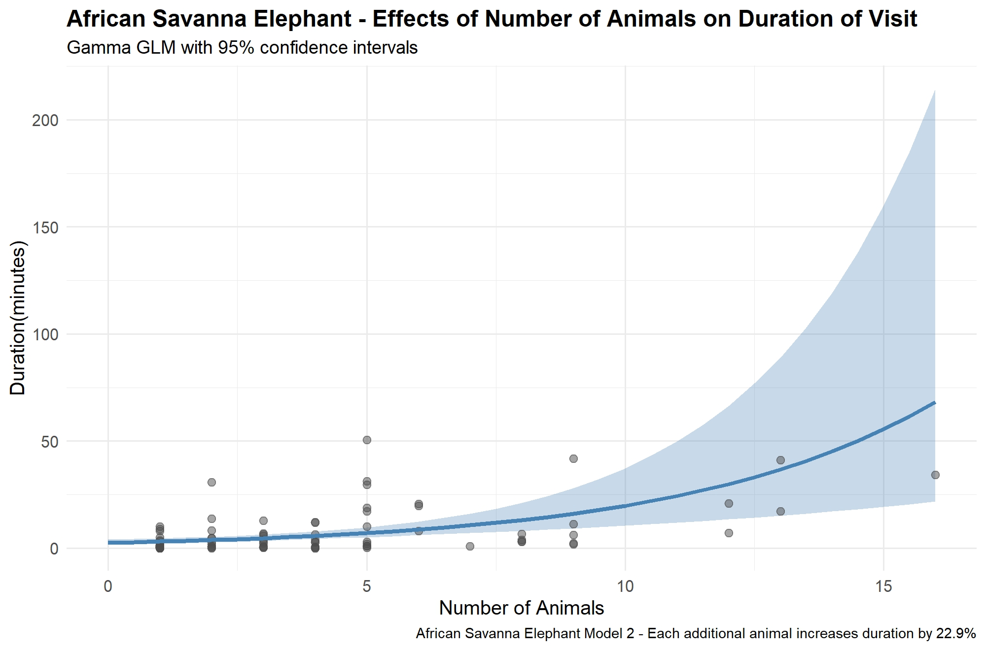
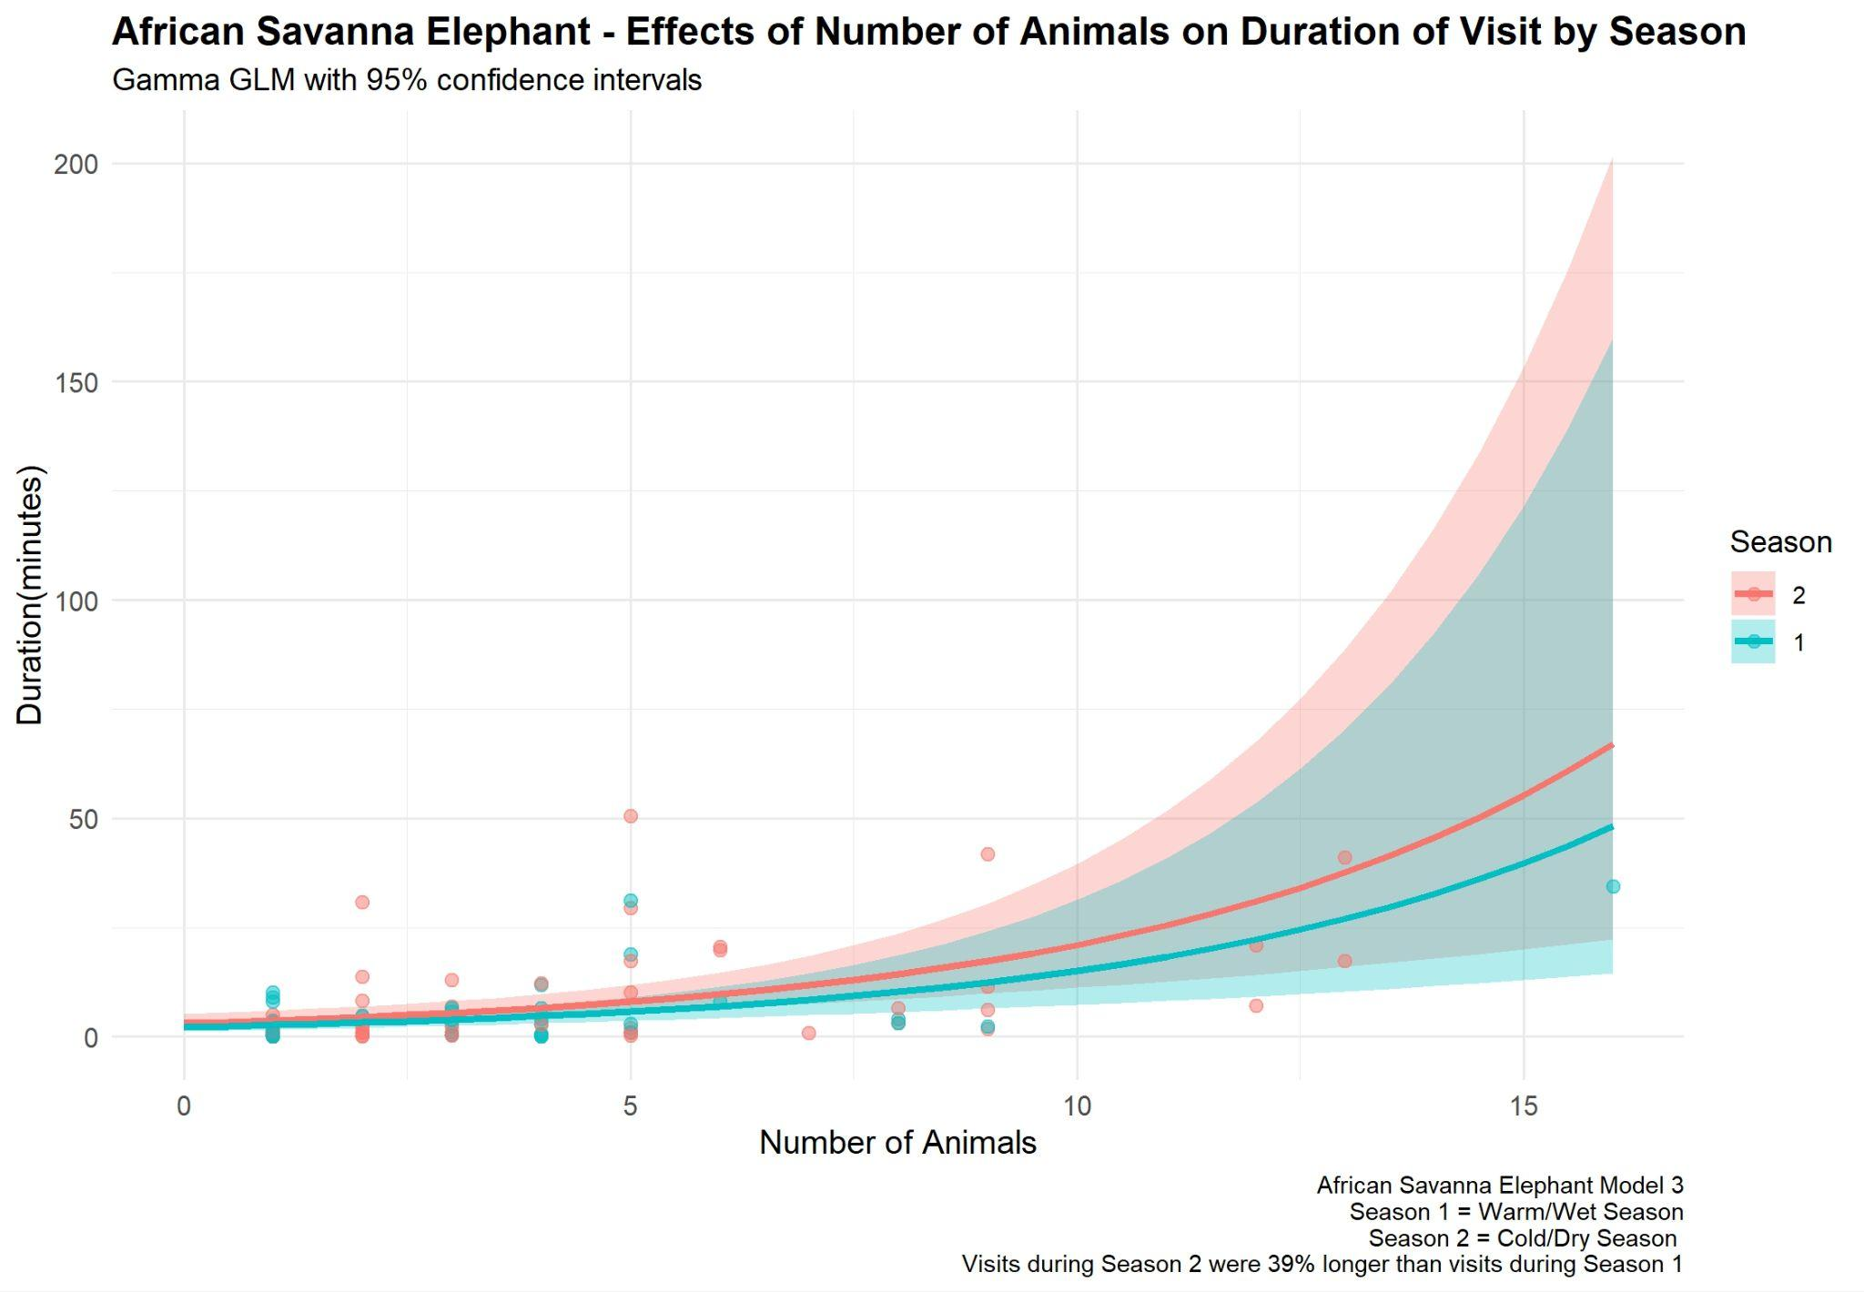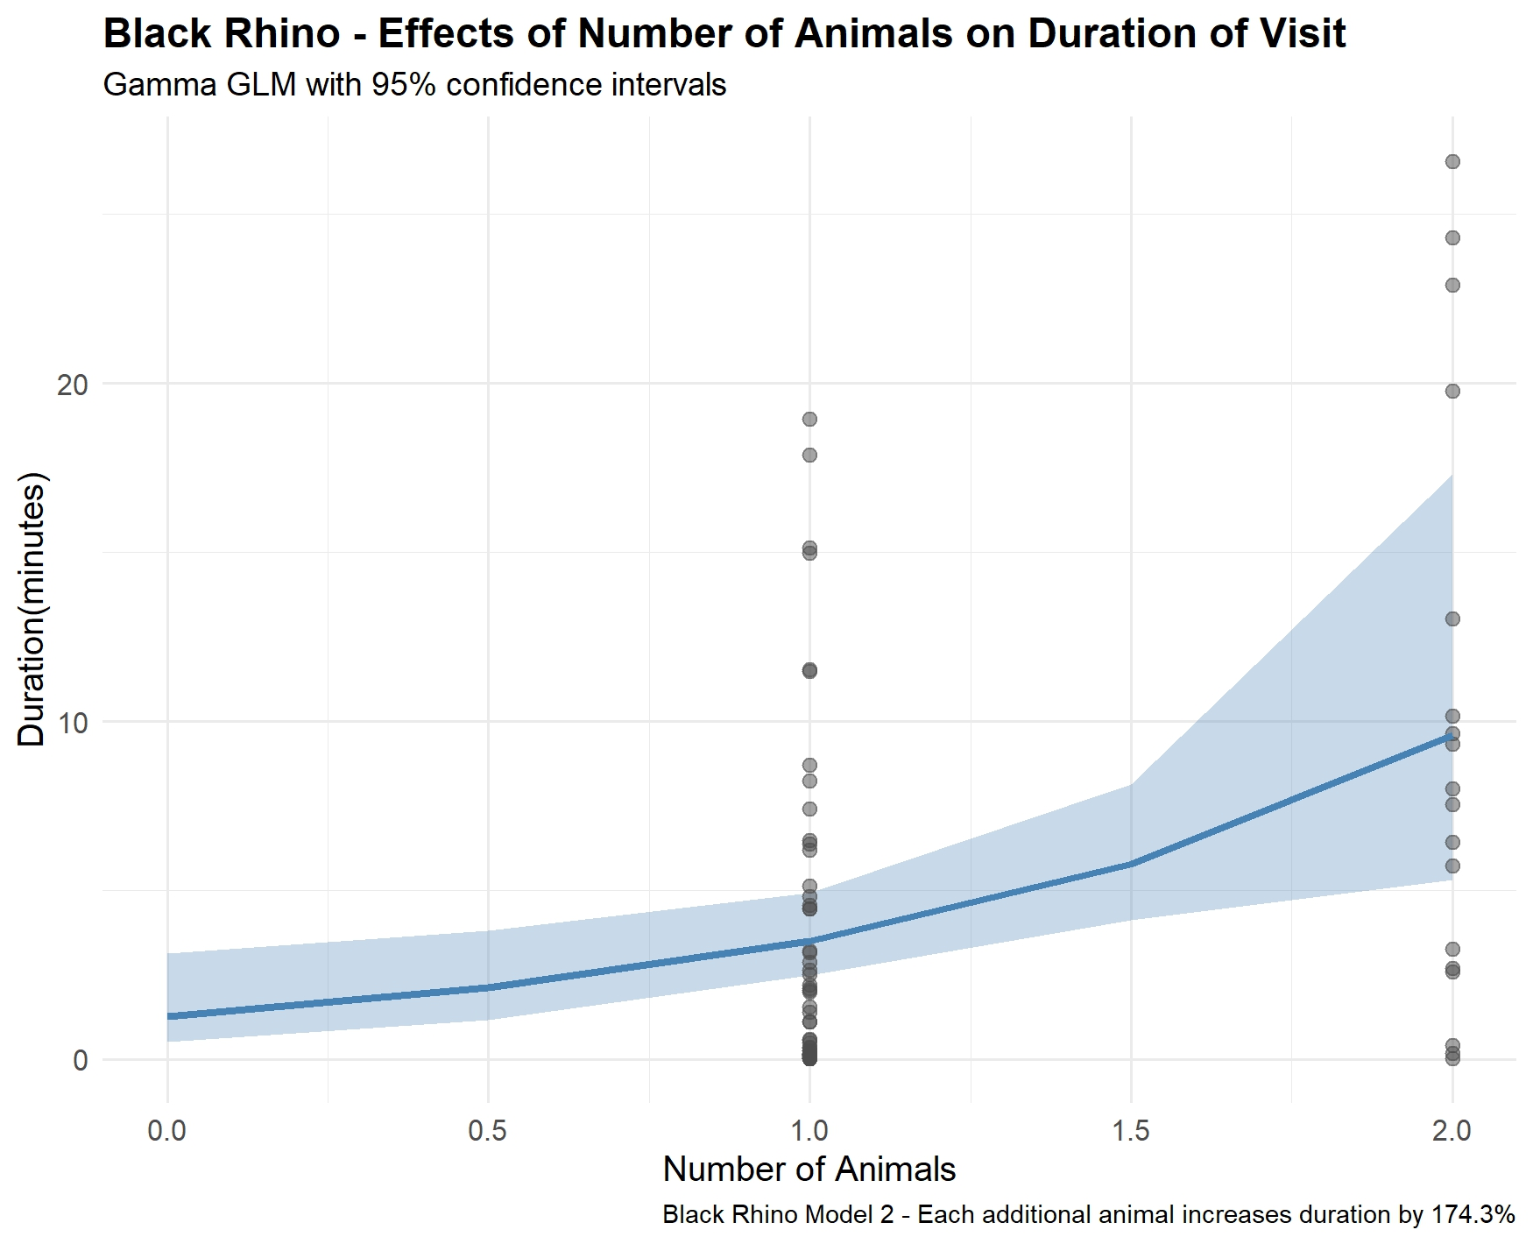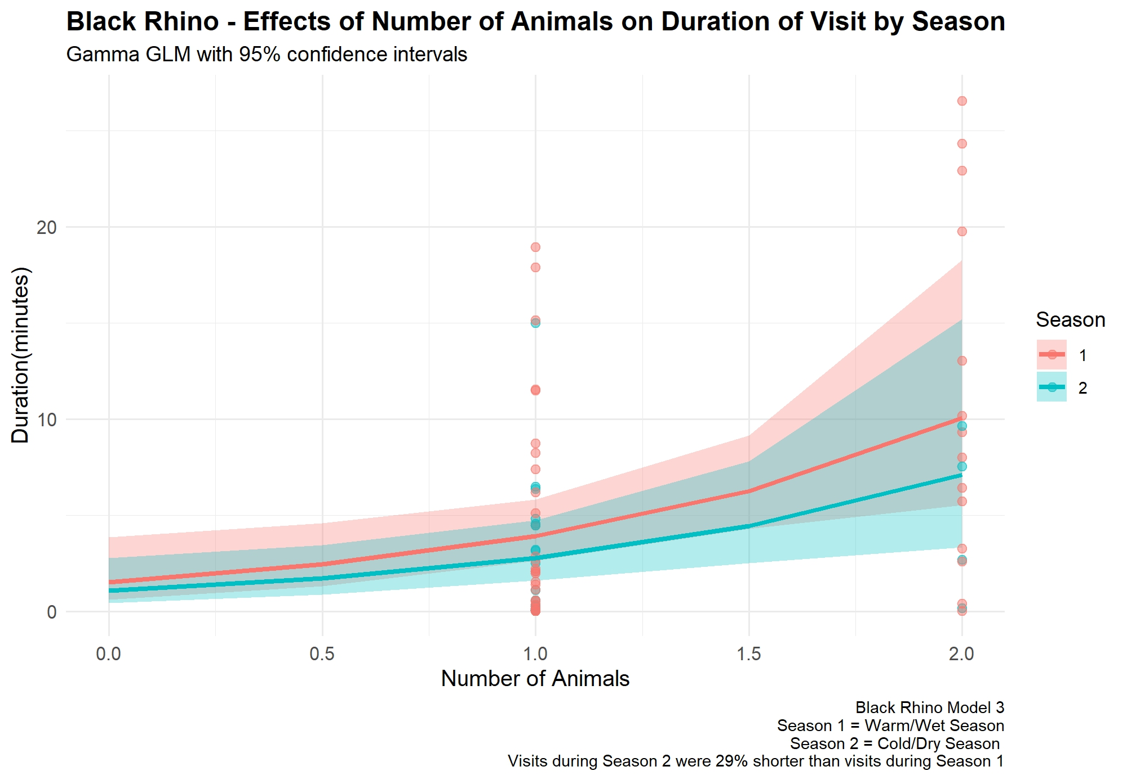

References
Chenay Simms. Kruger National Park - Basic Locational data. Updated 25.06.2025. Online GIS data. Accessed 08.12.2025. Online linkage: https://usflibrary.maps.arcgis.com/home/item.html?id=fd56576c675e4e4883805e1fe1a2dc54

Emslie, R. 2020. Ceratotherium simum. The IUCN Red List of Threatened Species 2020: e.T4185A45813880. https://dx.doi.org/10.2305/IUCN.UK.2020-1.RLTS.T4185A45813880.en. Accessed on 15 October 2025.

Emslie, R. 2020. Diceros bicornis. The IUCN Red List of Threatened Species 2020: e.T6557A152728945. https://dx.doi.org/10.2305/IUCN.UK.2020-1.RLTS.T6557A152728945.en. Accessed on 15 October 2025.

Esri. South African Province Boundaries. Updated 31.10.2025. Online GIS data. Accessed 08.12.2025. Online linkage: https://usflibrary.maps.arcgis.com/home/item.html?id=5b8071a043814d9783b0bb4819462991

Garrett Grolemund, Hadley Wickham (2011). Dates and Times Made Easy with lubridate. Journal of Statistical Software, 40(3), 1-25. URL https://www.jstatsoft.org/v40/i03/.

Gobush, K.S., Edwards, C.T.T, Balfour, D., Wittemyer, G., Maisels, F. & Taylor, R.D. 2022. Loxodonta africana (amended version of 2021 assessment). The IUCN Red List of Threatened Species 2022: e.T181008073A223031019. https://dx.doi.org/10.2305/IUCN.UK.2022-2.RLTS.T181008073A223031019.en. Accessed on 15 October 2025.

H. Wickham. ggplot2: Elegant Graphics for Data Analysis. Springer-Verlag New York,
2016.

H. Wickham. ggplot2: Elegant Graphics for Data Analysis. Springer-Verlag New York, 2016.

R Core Team (2025). _R: A Language and Environment for Statistical Computing_. R Foundation for Statistical Computing, Vienna, Austria. <https://www.R-project.org/>.

Smith E, Brown LR, Barrett AS (2024) Insights into artificial waterhole utilization patterns by elephants and rhinos: Lessons from a South African Nature Reserve. PLoS ONE 19(10): e0312158. https://doi.org/10.1371/journal.pone.0312158
Sutherland, W. (1998). The importance of behavioural studies in conservation biology,. Retrieved from https://www.sciencedirect.com/science/article/pii/S000334729890896X
Wickham H, Bryan J (2025). _readxl: Read Excel Files_. doi:10.32614/CRAN.package.readxl <https://doi.org/10.32614/CRAN.package.readxl >, R package version 1.4.5, <https://CRAN.R-project.org/package=readxl>.

Wickham H, Bryan J (2025). _readxl: Read Excel Files_.doi:10.32614/CRAN.package.readxl
<https://doi.org/10.32614/CRAN.package.readxl>, R package version 1.4.5, <https://CRAN.R-project.org/package=readxl>.

Wickham H, François R, Henry L, Müller K, Vaughan D (2023). _dplyr: A Grammar of Data Manipulation_. doi:10.32614/CRAN.package.dplyr<https://doi.org/10.32614/CRAN.package.dplyr>, R package version 1.1.4,
<https://CRAN.R-project.org/package=dplyr>.

Wickham H, Hester J, Bryan J (2024). _readr: Read Rectangular Text Data_. doi:10.32614/CRAN.package.readr <https://doi.org/10.32614/CRAN.package.readr>, R package version 2.1.5, <https://CRAN.R-project.org/package=readr>.

